

Enduring Wealth Built on Enduring Values
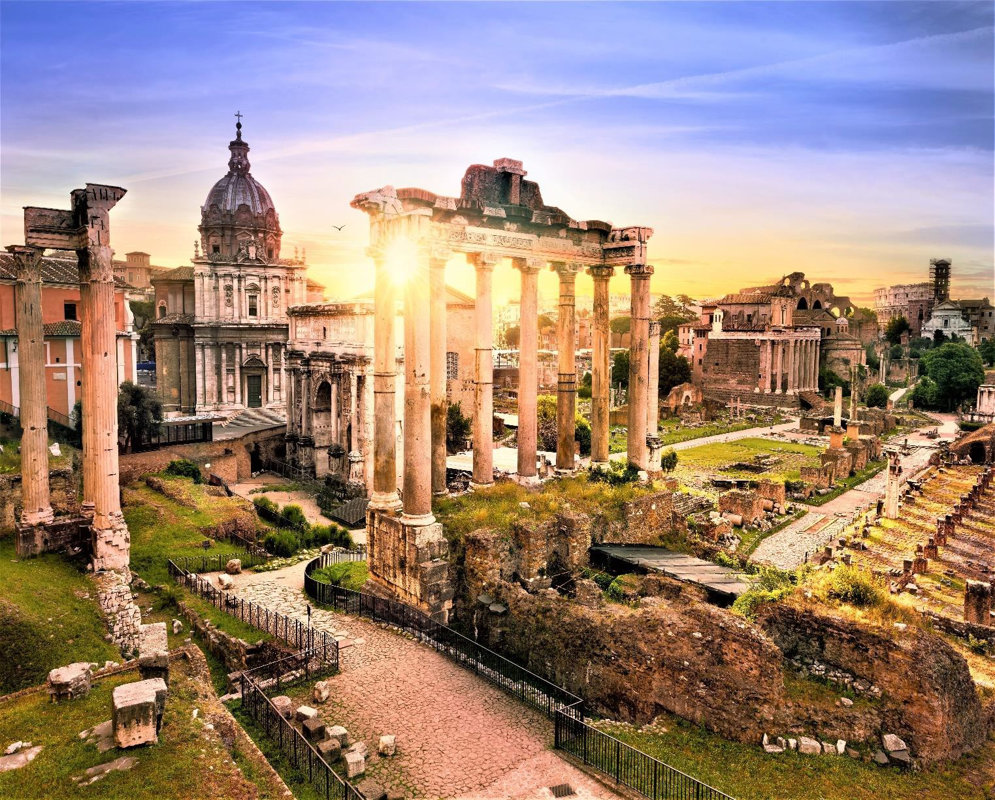

The FORUMs
Discover how you can partner with The Legacy FORUMs to build and protect your wealth, as you navigate the important issues of life.

The Legacy Forum’s prime objective is to work with our clients to build lives of virtue, purpose, passion, and enduring legacies.

The Legacy FORUMS are for individuals, couples, and families. It is expertly designed for people serious about the current state of their lives. You want your life and that of your family to matter. You understand the value of how hard work is necessary to create a strong and enduring Legacy. You are not
willing to leave the future to chance. You know it is necessary to build your future by seeking wise counsel. You choose to contact The Legacy Forum.
The Legacy Forum combines the two main concepts: Legacy and Forum.

LEGACY

Legacy is about your life and future. It's about learning from the past, living in the present, building for the future, and leaving your life as a pathway for the next generation to follow and build upon.
When people are serious about making their lives and the lives of their family matter, the word Legacy
defines that process. It demands thinking creatively and deeply about the future, how you want to live and move forward; the goals you wish to achieve. It is about what you are determined to bestow to the next generation.

FORUM

The Roman Forum was a physical place where life, in all it’s important facets, was explored. People shared their views on life, philosophy, politics, religion, and family. People bought and sold goods, went to court and watched triumphal processions. It was a place architected perfectly for that purpose. It sat between two of the seven hills of Rome, the Palatine and Capitoline hills. It was a valley,
somewhat secluded, but a place where important work was done.
Our FORUMS are held in specially selected places where we explore, discuss, envision, debate, set goals and discover more about who you are, where you are in your life today and dream about the wonderful future you can choose to create and live.

Our Clients Come to The Legacy Forum, Financially Protected, and Ready to Leverage Who They Are and What They Possess to Build Great and Enduring Legacies.

Wealth Alone -
A Curse

We know our clients are in great hands with expert financial advisors and lawyers. You have been wise, building and protecting your wealth. You feel proud of what you have accomplished.
Your greatest desire is for your family to flourish, be successful and find happiness. Wealth, however, does not equate to happiness nor by itself can it produce successful heirs.

As Legacy Forum Advisors, we have observed how this belief can give our clients a false sense of security. They erroneously think that expert financial planning equates to enduring wealth and thriving families. It does not!
Our purpose is to protect your wealth and help you devise strategies so that you will thrive personally and find enduring success and happiness. The Legacy Forum has developed a series of bespoke programs specially designed for individuals, couples and families.
Note: For wealth to endure, we believe it is important that wealth management firms provide clients with life enhancing resources. They are certainly not responsible for managing the personal
lives of their clients. A good knowledge of important referral sources, to develop and protect the virtues and talents of their clients, is a powerful indicator that wealth well managed is more than a financial portfolio. It views the client as equal to their wealth.

Wealth managers should not be responsible for anything beyond their fiduciary role, but they should be clear with clients that being an advisor to protect their client’s financial portfolio goes beyond providing fiscal and legal instruments.
Those opportunities are referrals that they can trust. Wealth managers must be confident they are all well vetted for their knowledge of Wealth Psychology, The Positive Psychology of Thriving and Wellbeing, talent development, Character development virtues and ethics, which are grounded in the highest levels of confidentiality.
David Green, the multi-billionaire founder of Hobby Lobby, was brave enough to say what we all know and tragically see all too often in UHNW families.

“Wealth can be a curse, and, in most cases, it is, if you drill down on it, wealth is a curse in terms of marriage, children, and things of that nature.”
In December 2017, Jan Berger, in Camden Wealth, talked about how the “Curse” manifested itself,
According to a 2019 survey of High and Ultra High Net Worth Families, 71 percent of respondents admitted they are aware of or were directly affected by a family member’s struggle with mental health or addiction. 84 percent said they are concerned about potential damage to the family’s reputation. Without exception, all expressed concern about the destructive potential of bad decisions fueled by substance abuse.

The Antidote -
The Legacy FORUMS

At The Legacy Forum, we know how to build the internal structure of a family, so they can enjoy their wealth. We help them thrive as individuals, create a world better than they were born into, live a life of service and have their lives extend beyond their last breath.

If your only focus is on the security and growth of your portfolio, you will likely never enjoy all your wealth can afford you.

In equal measure, those who exist within the structure of that portfolio must have protection and robust strategies for the growth and development of that wealth.
With this in mind, The Legacy Forum, a pioneer in providing concierge services to UHNW individuals
and families, is now offering three distinct bespoke programs, designed to create the environment for your Family Wealth to endure.
These programs are not focused on financial wealth but the enduring wealth of values, faith, service, and character. Succession planning for wealth alone and not values will be cursed and those who are the subjects of that planning will have cursed lives. Just look around you.
Where they are strong, they must have succession plans and education for this current generation to live them when you are gone. Where they are lacking or weak, strategies must be expertly designed to build them into those who will inherit the wealth.

The Enduring Legacy Model
(Description)

The Legacy Forum’s Enduring Legacy Model has been built from over thirty-five years of experience working with individuals, couples, and families. It was developed by Mark R. Demos, Founder of The Legacy Forum.
It involves asking many incisive questions that are well thought out and expertly constructed. Both Founders, Mark R. Demos and Krisandra Parsons
Demos, LPC (Licensed Professional Counselor) for over 25 years, have spent many years working in areas of Forensic Psychology specifically related to Forensic Profiling and interviewing. Mark wrote the book, “The DNA Code, The Forensics of Passion, Purpose and Performance”. The book is based on his Positive Psychology model of Positive Forensic Profiling.

"The DNA Success Code by Mark R Demos, is all about navigating through the toughest situations, to decisions about profession, education and parenting and ultimately defining your course in life...discover Evidence of your Talents and apply them to creating a life filled with the three important "P's": Purpose, Passion and Performance."
Dr. Elizabeth Loftus Ph.D. - Past President American Psychological Society and Distinguished Professor of Psychology and Law. University of California, Irvine. Recognized as the most prominent Female Psychologist of the 20th Century.

The model follows a very simple but powerful structure. Analysis, Inventory and Direction. (AID) It is a simple acronym to remember. This will act as an AID in the construction of your own personal Enduring Legacy.
What is also important for you to understand, is that as we work with you in building your Enduring Legacy, the model starts with “A”. We essentially look backward to your history from two distinct vantage points. We know from experience that there will be parts of your history that can be very difficult to return to emotionally; there are likely people and events in your history you would rather not remember. We understand that and want you to understand, though we may look at those situations and people, they are not the true focus of your history. But we must be sure that those traumatic and negative events and people are not holding you back from living fully today and moving forward in a positive way. It has been wisely said, “The past is only the past when it is in the past”.
The work we will do with you that looks at your history is divided into two primary parts: negative history and positive history. There is a well-known saying by philosopher Santayana, that states, “Those who refuse to learn from the lessons of the past are doomed to repeat them”. We must learn lessons well, so we know what to avoid and also failures we need to leave behind. Knowing we have
learned the lessons that resulted in pain, problems, and loss; is an element of the foundation on which you will move forward and build a strong foundation.
Looking at the past should be very liberating and freeing. We see clients become alive when the burdens of the past are for the most part resolved. When relationships have been restored, debts paid, forgiveness accepted and given. We want to make sure, as much as is possible, the issues of the past do not slow you down or erode your foundation for building an Enduring Legacy.
The second essential focus of history is best described by the positive restatement of Santayana by Mark Demos in his book. It reads, “Those who choose to learn from the right choices, best actions, most powerful decisions, positive relationships, achievements, etc., are destined to repeat them”. When we know and can stipulate as to what works, we can count on them to be used for a foundation of strength and resiliency.
CONFIDENTIALITY: We want you to know, everything you share is held in the strictest confidence. If you are attending a group Legacy Foundations FORUM, you can write down issues you may wish to keep private from the group. Those issues can be noted and reserved for you and your Advisor to discuss together in one of our post- retreat sessions.

The FORUMs

Here are brief descriptions of the FORUMS we currently offer. To talk in detail and have your
questions answered, please contact The Legacy Forum.

FORUMs | Description | Legacy Program Format
The Legacy Journey  FORUM | The Legacy Journey is our premier program. It is for individuals, couples, and families. The purpose is to work on building an Enduring Legacy by focusing on each major element of Legacy Building, in a deep, strong, and purposeful manner.  The program is 12 months in length. You can begin at any time throughout the year. Because it is a very exclusive service, there often is a waitlist. If you are interested, contact us. | The Legacy Foundation Retreat is the first of four retreats. It lasts 5-6 days. The purpose if for us to start building your Legacy’s foundation.  - Pre-Retreat - 3-4 Zoom sessions  - Post-Retreat - 20-25 Zoom sessions scheduled between the three mini retreats.  - Mini Retreats will be scheduled at 3-4 month intervals, and are 2-3 days long.
The Legacy Foundation  FORUM | The Legacy Foundations follows the same structure as The Legacy Journey but is delivered in a shorter format, over 100 days.  Legacy Foundations can be experienced individually, as a couple or in a group of 6 or less. One to Three couples may attend or 5 individuals or one individual. Please call to discuss which option would best meet your needs.  Some people wish to continue to The Legacy Journey FORUM after The Foundations FORUM. Please contact us to discuss this option. | The Legacy Foundation Retreat lasts 4-5 days. This is the primary and only scheduled retreat for this program.  - Pre-retreat, 2-3 Zoom sessions.  - Post-Retreat, you will experience 10 weekly Zoom sessions with your Legacy Advisor. These will focus on integration of the AID model and formulation of your Legacy using the SPIES holistic formula.  - A short 2-3 days retreat is an option that can be added on.
The Legacy Quest  FORUM | The Legacy Quest is designed for young adults, 22 to 35 years of ages. Many participants are struggling to launch, figuring out where they fit in this world; many lack any real sense of purpose and most are anxious and scared of the world in which they live.  The Legacy Quest is uniquely designed to focus on the discovery of the talents and character strengths of each individual as a pathway to becoming strong, giving and exceptional leaders in their families and solidifying their future legacies.  The program has been developed in consultation with one of our Advisors, Charles Bartlett, MBA, MCMH (In progress). Charlie is 30 years old and the grandson of the founder of Franklin Resources and majority owner of The San Francisco Giants baseball team. | The Legacy Foundation Retreat lasts 4-5 days.  - Prior to the start of the retreat, we will schedule 2-3 Zoom sessions to prepare you.  - Post-Retreat, you will experience 10 weekly Zoom sessions with your Legacy Advisor. These will focus on integration of the AID model and formulation of your Legacy using the SPIES holistic formula.  - Some of our clients continue working with us on a month-to-month basis after the FORUM ends. They continue to explore college, career, relationship, and other important issues.  Please contact us to discuss if you are interested in starting your Legacy Quest.
*The Conversation is a new unique offering, starting in the summer of 2024. This Transatlantic Crossing on Cunard’s
Queen Mary II, is the perfect venue for slowing down and having conversations about the things that matter most, your Enduring Legacy. The Conversation brochure is now ready for clients. If interested, please ask your advisor.

The FORUM
Process

A
Analysis - The Past.
Leaving Behind the Negative and Banking Positive History
I
Inventory - The Present
My Total Wealth, including My Financial, My Talents, Strengths and Values
D
Direction - The Future
My Legacy. What Do I Want to Build? How Do I Want to Serve Others? Where do I want to Go?

“It is said that the examined life is the one most worth living. But how are we to examine life? ‘The DNA Code: The Forensics of Purpose, Passion and Performance’, by Mark R Demos, uses the metaphor of forensic science to provide a wealth of practical and provocative tools for examining ourselves and living better. I recommend this book most highly.”
Dr. Christopher Peterson, PhD, Professor of Psychology, University of Michigan–Ann Arbor and author of A Primer in Positive Psychology, Oxford University Press.

Enduring Legacy Model | Description
A  The Past Analysis | Legacy is built upon the foundation of the Past. It is all that has happened up to and until today, this moment! It is the history of you and your family.  Building an Enduring Legacy sometimes requires elements of the past be addressed for individuals and families to be able to focus on the present and build for the future.  We believe that both negative and positive must be identified and managed. The Legacy Forum believes that the most important information in our histories, is based on the positive: actions, decisions, relationships, values, changes, courageous actions, and reputation. We call this an “Analysis of Asset”. To build on a strong foundation, without having to look in the rearview mirror, means we learn from the mistakes of the past but build and develop the positive actions of virtues, faith, values and courage.

I  The Present Inventory | Taking a thorough inventory of the PRESENT is the basis on which strategies of growth and development are founded.  Financial wealth is one part of that inventory. It is agnostic in terms of value. How it is used determines whether it will become a blessing or a curse. Whether it will dissipate into nothing but ruined lives and reputations or become a powerful platform for exceptional lives and Enduring Legacy. That is the choice.  Each individual family member is assessed for their innate Talents, Strengths, and Values. Talents are hard-wired positive attributes that when used bring a sense of mastery and FLOW to the individual’s life. Strengths are character and motivational attributes. These can be taught and built into our lives.  Talents driven by values and character leads most often to lives of meaning, passion and purpose. That is what great Legacy is built from.
D  The Future Direction | The past is now better understood and managed. Our resources are now ready to be deployed with values, examined motives and with clear intent. We now have an open road to discover and build a life of Purpose, Passion and Enduring Legacy. The FUTURE.  Hope Theory tells us that desire for a positive and successful FUTURE, by itself, is nothing more than wishful thinking. But if we assess our resources and wisely allocate them to craft a well though-out plan to achieve it, Hope will likely be realized, and an Enduring Legacy built.

A - Analysis
- Knowing where you are in terms of your age and historical context within your family. Who is my family and who am I within my family?
- How did I get to where I am today, at this moment?
- Chapters of my history. What would those headings be?
- Chronology of my family members lives and deaths.
- The Decades of My History – Short paragraphs and descriptions.
- Three generations of my family history as peers. Ages when they died and description of their greatest accomplishments, virtues, and character.
- The Days of My Life – counting and projecting
- What do I want to carry forward and build upon.
- What do I need to accept, write-off, come to peace with and leave behind?

I - Inventory
Inventory is doing a deep dive into who you are in terms of your Hard-Wired Talents, Motives, Virtues, and Character in all the five essential elements of who you are. This is done using the SPIES model, also developed by Mark R Demos.
You will be taken through one of the most powerful life-discovery and enhancing processes, The Positice Forensic Talent DNA Profile©. The question, “Who are you or Who am I?” must be answered.
This model will take you through a proprietary process of identifying your innate Talents and Strengths. This will be performed in five areas of your life: SPIES looks at five dimensions of our experience as humans.
- S – Spiritual – Faith, Values, Motivations
- P – Physical.
- I – Intellectual.
- E – Emotional.
- S – Social.
There is one additional area we will ask you to factor into this analysis, your financial wealth portfolio. We will not ask you for any details. The reason we

need to talk about it is because as we move to the next part of our Enduring Legacy Forum, “Direction”, we will be looking at how you wish to develop your Legacy.
As we have stated money is not and cannot be the source of happiness for anyone. By itself it is neither good nor bad, positive, or negative. But we know with absolute certainty, money must be combined with values and actions or virtue to ever hope it will provide the future and Enduring Legacy, we believe you deeply hope to create.

D - Direction
- The future, starting with the context of both the past and present, is where most of our time will be focused. It is exciting because knowing the past is now well understood; dealing with anyone or any issue that could sabotage or slow down your desire to build an Enduring Legacy, is now left in the past or managed well.
- You will have performed a thorough Positive Forensic Talent DNA Profile© to understand what Human Capital you and your family possess as assets for Legacy Building.
- You will begin to plan how to deploy both your financial and human assets.
- You will dream about how to build not simply by funding opportunities, but about how your lives can serve others.
- What can I do with what I have and who I am? What will the combination of the best
use of my talents, my motives, virtues, and my ability to fund, be able to achieve? What do I know will change lives and build my Enduring Legacy?
- Direction is a time of creativity. A time to dream. A time to envision possibilities. How can you and your family leave their mark in this world? Innovation and creativity sessions and retreats are part of The Legacy Journey FORUM and also are options for our other FORUMS.
- Developing our Prime Directive as an individual or family. It is a guiding body of virtues that you believe are most important and best defines your Family DNA.
- We encourage that you design and create a family Coat of Arms, a symbol used to identify your Family History and Virtue DNA. It should include a motto that is the defining statement of your family.
- We encourage that you begin a Legacy Journal towards the end of The Legacy Journey FORUM. In it you can write more of your history, what you are most proud of, what you want your family and others to know about you. It is a journal of the very best of you!
- The Legacy Forum will provide you with specially designed journals throughout the FORUM journey.

Interested in
Participating in a FORUM?
Interest in participating in The Legacy FORUM begins with an application process. The purpose is to determine if we are a good fit for you, and a good fit for what we do at The Legacy Forum.
The work we do in our Legacy FORUM’s is in many ways sacred. We believe that each day of your life has great value. We also believe our

talents and experience should only be used by giving them to people who are serious about their Legacy and serving others. We both only have one life. As we look forward to the future, neither of us have time, talent, or wealth to waste.
We are determined that the clients with whom we work, build lives that are exceptional, not just because of the wealth they possess, but because they are determined to build Enduring Legacies of substance and service to others.

Interview Process
- The interview and application process begins with you contacting The Legacy Forum and discussing which FORUM you are interested in.
- We will send you information and an application specific to that FORUM. The application should be completed before we can move forward with any discussion of your participation in that FORUM. We will also share the cost of your desired FORUM and how we manage those payments.
- A Senior Advisor will reach out to you and schedule a Zoom call. During that call your responses will be discussed. You will be able to ask any questions you have regarding how the FORUM works and how you can participate for the best outcomes.
- No final decision regarding your participation will be made during that first Zoom call. We will both have a week before we can either affirm a desire to move forward or a decision not to proceed. Any questions you have can be answered by calling us or emailing.
- If a mutual decision is made to move forward, we will discuss when and what is required to start the most exciting and powerful journey of your life.

The Pre-FORUM Process
- Pre-Retreat, each FORUM essentially starts in the same way.
- You will be given information on preparing for the Legacy Journey, Legacy Quest, or Legacy Foundations FORUM.
- You will begin pre-work that includes:
  - Biographical information.
  - Statement of purpose for participation in the FORUM.
  - Working on exercises in a Legacy Journal you will use throughout your FORUM.
  - Taking The StrengthsFinder Profile, The Values In Action Profile and The PERMA-H Profile Assessment.
  - What are your desired outcomes for participating in the FORUM?
- Start dates will be finalized.
- Venue finalized.
- Flights or transportation finalized.
- A number of Zoom calls will be scheduled prior to each retreat. The number will depend on the FORUM you are participating in.

FORUM Venues
There are a variety of options regarding FORUM venues.

Legacy Quest and Legacy Foundation group FORUMs will be hosted at venues selected by The Legacy Forum. The venues have limited space, with no more than five individuals or three couples at any one FORUM.
*The cost of the venue for The Legacy Quest and
Legacy Foundations is included
The venues are at stand-alone homes, or retreat settings. There are few to no distractions. They are selected for their quiet, beauty and ability to focus on our work of Legacy.
The Legacy Journey FORUM retreats, have the option of being hosted at venues selected by our clients. Most of our clients have homes or other options at which to host retreats. We do have a number of important criteria for the FORUM to be successful. These will be shared with our clients if necessary.
The Legacy Forum partners with a number of companies that specialize in finding venues perfect for our clients.

The Conversation
The Legacy Forum has always been highly innovative. We have looked for ways to meet the needs of our unique clients, in ways that fit their lifestyles, in venues that are most conducive to change, and with the highest levels of privacy.
One of these innovative options for a bespoke FORUM, is The Conversation. This is a journey unlike any other. The venue is a voyage on the Trans-Atlantic QE II Cunard Line.
The Conversation is a journey, a choice to escape the real world and indulge in conversations about life’s most important personal issues.
It is a conversation in iconic old-world luxury, about building a Legacy, that just like this voyage has lasted many generations and holds true to values that have endured.
This exclusive option must be booked at least 45 days before sailing, with the first departure in early May 2024.
The Conversation is limited to one individual or couple at a time.
The journey is 7-9 nights, departing from New York and sailing to Southampton in England or Hamburg in Germany. The ship and cruise-line epitomize the nature of Enduring Legacy.
Please contact us without delay if you are ready for The Conversation that will change your Legacy for generations to come. But do so early!

Contact The Legacy FORUM
To begin your discussion with The Legacy Forum, please either call Mark R Demos (425) 492-4300 or email mark.demos@thelegacyforum.com

“The Wise man built his house upon the rock, and the house stood firm…The foolish man built his house upon the sand. The waters rose, the winds blew and beat against the house, and it fell with a great crash.” Jesus Christ

Addendum
The Legacy Forum will offer a complimentary session to interested clients that is informational in nature. Potential clients who are looking to build enduring Legacy will have the opportunity to speak with one of our Senior Advisors. Any questions the clients may have about a particular program will be answered and the format and cost will be discussed.
Confidentiality
The information we receive from our clients is sacred. It is held and protected by us and only used for your good. There are times we will seek permission for specific information we believe is necessary so we can work with you in the most appropriate way possible. We will always seek your permission. How we do that is based on your choice of mode of communication. Some clients do not wish for us to retain written records.
It is also important to understand the nature of the work we do as Advisors. We deal with all the issues of life presented to us by our clients. Some are very personal and for our ears and eyes only. There are times we may advise you to seek professional help from one of our network or psychologists, psychiatrists, or Licensed Professional Counselors. Growth can at times be accomplished best in a closed forum. There are times where you may need from a licensed attorney or other professional help to deal with a serious matter. We understand you still have your financial advisors and any issue related to your financial portfolio must be dealt with by them. The Legacy Forum is NOT a financial services firm.
Mark R. Demos is also a minister of religion. We have experienced times where clients have sought a place where they need to talk about issues of the highest confidence and know that what is said cannot be revealed to any agency or court as it is given under cover of “The Confessional”. This is not an option to be used frivolously but only with sincere motivation and honest intent.
Reporting. Any report that TLF may provide is at your request and is for informational purposes only and should not be relied upon; it is not your personal statement.
This material is intended for educational purposes only and is provided solely on the basis that it will not form a primary basis for any investment decisions. Any materials and/or analyses provided to you are based on the assumptions stated therein. In the event any of the assumptions used do not prove to be true, results are likely to vary substantially. TLF will not be responsible for the accuracy or completeness of any such information, nor for any consequences related to the use of any inaccurate or incomplete information.
Examples shown within this material are for illustrative purposes only and no representation is being made that any client will or is likely to achieve the results shown. This material may not, without TLF’s prior written consent, be (I) copied, photocopied, or duplicated in any form, by any means, or (ii) distributed to any person that is not an employee, officer, f the recipient.

